Operating Systems: Simplified Lecture Notes: Lecture 1

# 1. Introduction to Operating Systems

## Formal Definition

An operating system (OS) is a piece of software that manages all the resources of a computer system, both hardware and software, and provides an environment for the user to execute programs conveniently and efficiently.

## Layman Explanation

Think of an OS as the 'manager' of your computer. It’s like a hotel manager who ensures guests (programs) use hotel facilities (hardware) properly, without any clashes. Without an OS, programs would have to manage hardware on their own.

## Flowchart of OS Functioning

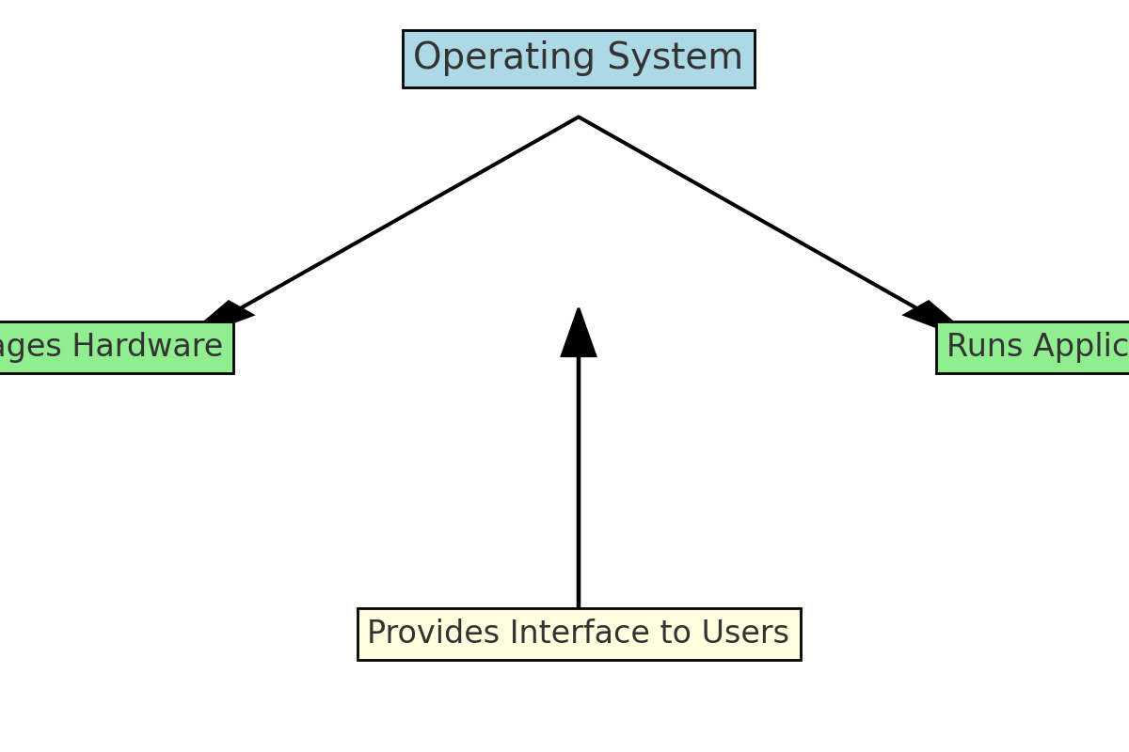

## Real-life Example

Imagine a library. The librarian (OS) ensures that books (resources) are handed out to people (applications) in an organized manner. Without the librarian, people would be confused, and some might hog all the books while others get none!

**Examples of OS** - Windows, Linux, macOS, Android, iOS